ANSTEY DISTRICT GARDEN SHOW
WEST ANSTEY VILLAGE HALL, YEO MILL
Saturday 13th August, 2016, 2.30pm

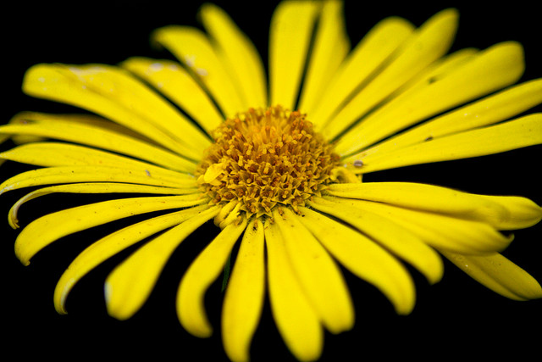

Free pass for exhibitors entering 10 or more events – anyone can enter – and new entrants are always welcome. Cut flowers/decorative, Produce, Handicraft, Childrens section – something for everyone.
Schedules and entry forms have been sent out but further copies available from Phyll Wynn 01398 341562 or Sylvia Barber 01398 341624. Entry Fees: all classes 20p per class. Entries to be sent or handed to any Committee Member by 1 pm Tuesday 9th August.

Exhibitors setting up times - from 9 am – 10.45 am on the morning of the Show.

DOORS OPEN TO THE PUBLIC 2.30 PM
Admission to Show: Adults £1 Children free
DRAW TEAS/CAKE Sale Table for donated Produce
Presentation of Cups and Prizes

